# Converting a c#/.Net web app into a js/svelte/react web app

* All tables are stored in an Azure SQL database
* Credentials to connect to the database will be provided after signing the NDA. Those credentials are have read-only access to all tables beside the PIN field of the T_Personen table
* The .Net project will be provided for comparison
* Single language web app (German)
* There are 5 tables available
  + T_Personen: personal data of the member of the mosque
  + T_Familie: data of the family members of members of the mosque
  + T_Mitgliedschaft: yearly (multiple payments possible) membership payments of a member
  + T_Fondi: yearly (multiple payments possible) payments for the funeral insurance
  + T_Spenden: other extra payments, not bound to a year
* Login Screen
  + 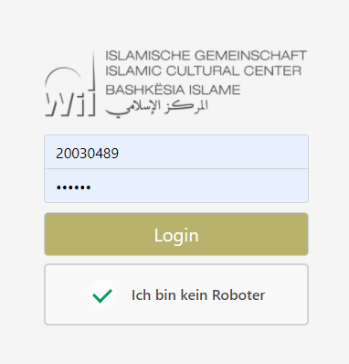
  + Nr and PIN must match in order to retrieve data of the member with that particular Nr
  + Google Captcha V3 check
  + Remove the “I am not a robot” checkbox if not necessary
* Header
  + 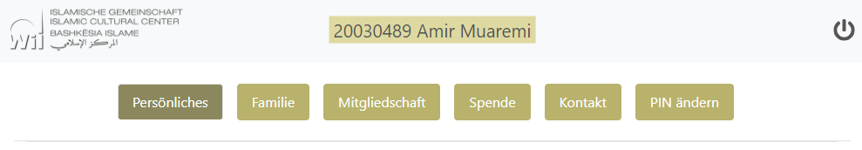
  + Keep color and logo, the design itself can be adapted
  + Each button represents the data of a table from above
* Persönliches
  + 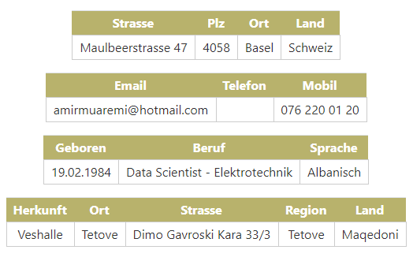
  + Create a tall list instead of a wide table to look ok on the smartphone. Cluster the fields into the four categories shown above (add vertical space between the four categories)
* Familie:
  + 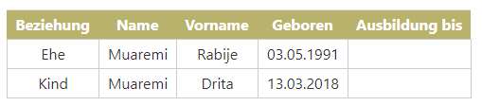
  + The table would look OK on smartphone without the column “ausbildung bis”. Any idea how to display the whole table nicely on the smartphone? In most of the cases the Ausbildung bis column is empty. How about removing that column but display a mini-table below the main table called “Ausbildung” with Name+Vorname and Ausbidlung-bis as columns names?
* Mitgliedschaft
  + 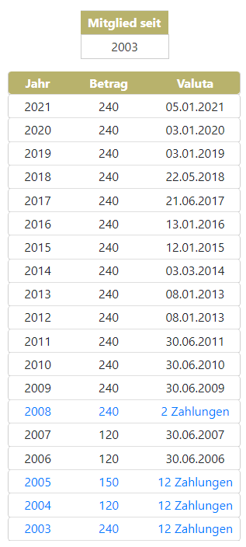
  + Mitglied seit is the year of the MitgliedSeit column in T_Personen
* Bestattungsfonds
  + 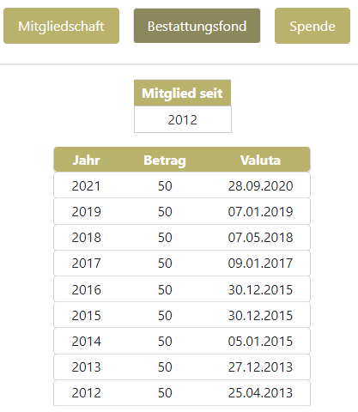
  + This category is shown only if FondiNr in T_Personen is not empty
  + The looks the same as Mitgliedschaft
  + Mitglied seit contains the year of the first payment, e.g. 2012 in the example above
* Spende
  + 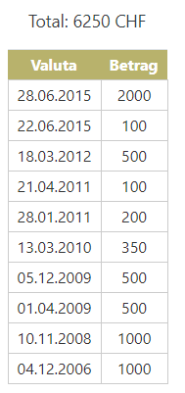
  + The total is the sume of all payments
* Kontakt:
  + 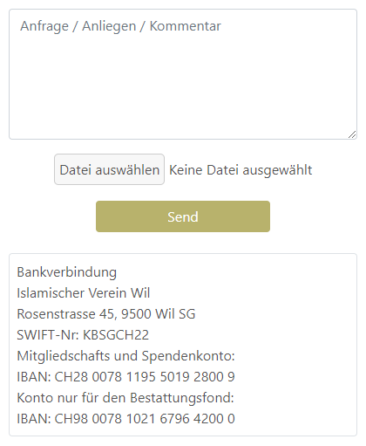
  + Send an email from a @mosche-wil.ch email to another @moschee-wil.ch
  + Check .net project for details
* Pin ändern
  + 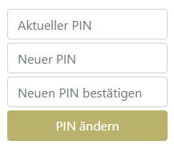
  + At least 6 characters pin
  + Stored as hash in the table